**Documentation for Constellations of the Commons Proto Site:**

**Using Neatline for Visualization**

**Neatline Exhibit: Homepage Visualization**

* The outerspace background is a static image layer that overrides the default spatial layer of the exhibit. You can modify the background via *Exhibit Settings* under this exhibit’s information. If you want to replace this image, I recommend finding an image of similar dimensions or else the scaling of the new image to other existing objects will get funky. Web accessible location of current background image: <https://cdn.spacetelescope.org/archives/images/publicationjpg/heic1112d.jpg>

**TOP LEVEL: LEVEL 2**

* 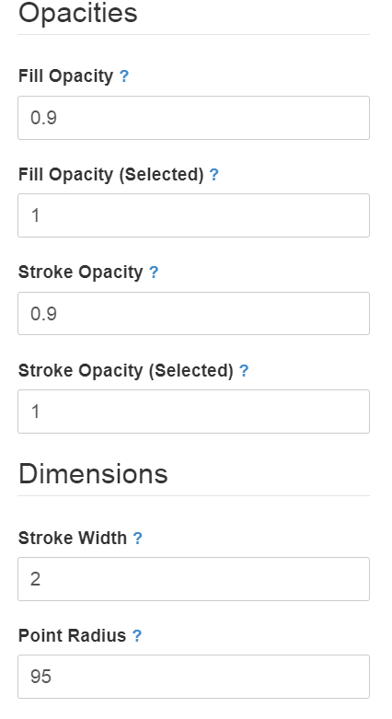The thematic nodes (yellow circles titled Migration, Urban Planning, etc.) are point images that link to the corresponding *Exhibit* for each theme—upload the image for each node as an *Item* to the Omeka repository to produce a corresponding Omeka web-accessible link (e.g[. http://neatline.celestesharpe.com/files/original/ 7f49689dfc1ae2e6474ef828a5906c7a.png](http://neatline.celestesharpe.com/files/original/7f49689dfc1ae2e6474ef828a5906c7a.png)) and set that link as the node’s *Point Image*. Make the node display in the exhibit via *Draw Point* under the *Map* tab for the node Record. The *Style* guide for the nodes is pictured to the right.

A node Record’s can be linked to its *Exhibit* by editing the *Body* section of the *Text* tab per Record (there is an HTML interface option here for including hyperlinks and images). The link will appear in the informational popup for the Record.

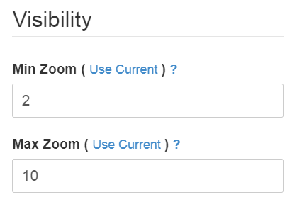

To create a new image of a node with different text, screenshot the sample node above with the desired text. Using an editing tool, crop the image so that only the node appears on white background. Then, upload the cropped image to this link: 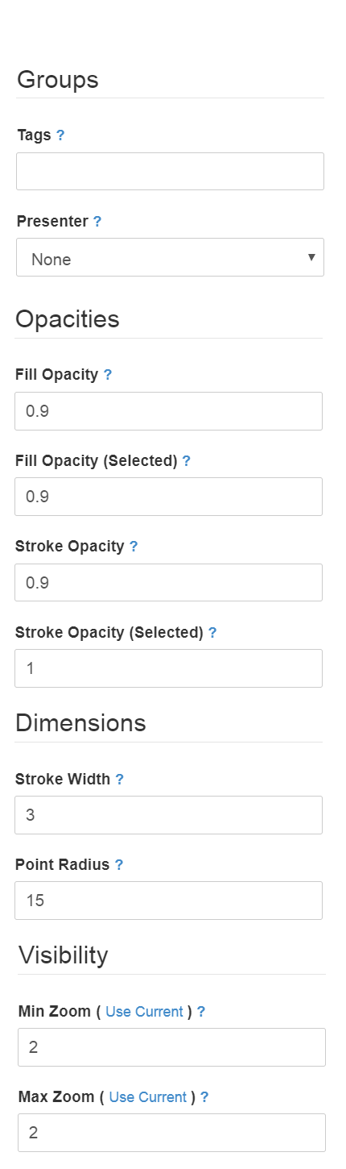<https://www196.lunapic.com/editor/?action=transparent> to make the white background transparent. Save the new image as PNG for later upload to Omeka.

* The backlighting for each node Record is actually its own independent Record, again a point image displayed via *Draw Point*. Web-accessible location: <https://cdn130.picsart.com/243049200049212.png?r1024x1024>

*Style* guide reflects that of the thematic nodes, except the *Presenter* is set to None, the *Point Radius* is 200 and the *Z-Index* and *Order/Weight* are 1 (under *Dimensions* section of *Style* tab for each Record). The indexing and ordering allows the backlight to appear underneath respective node Records.

* The small stars representing grassroots groups and organizations make up a single Record encapsulating all the groups. Each star is a point image displayed via *Draw Point*. The *Style* guide is pictured to the right. These stars should not be able to trigger informational popups (so the *Presenter* is set to None) and should only be visible at the top level of 2. Web-accessible location of image used: [http://neatline.celestesharpe.com/ files/original/96cd3baf187cdaa5fdf3e7b5a270cab9.png](http://neatline.celestesharpe.com/files/original/96cd3baf187cdaa5fdf3e7b5a270cab9.png)

**BOTTOM LEVEL: LEVELS 3 – 10**

* Unlike organization at the top level, each star representing a grassroots group is now its own Record. The star imagery is a Neatline polygon, defined by the following *Spatial Data Geometry (Well-Known Text)* under the *Map* tab per Record:

GEOMETRYCOLLECTION(POLYGON((698.2705834295666 1341.0817175639559,722.732485395209 1320.1143730219596,665.0722879047682 1330.59804529292,727.9743215307042 1355.0599472585702,677.3032388875856 1304.388864615444,686.0396324467494 1367.2908982413564,698.28330900536 1340.8265962115,698.2705834295666 1341.0817175639559)))

This block of text will place the star polygon in a specific location on the exhibit. The star can easily be moved to where you desire via *Drag Shape* under the *Map* tab.

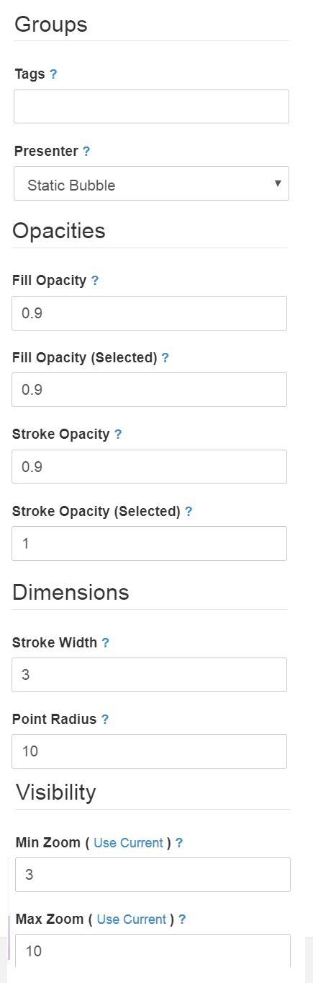The *Style* guide is pictured to the right. Note that a star’s placement on the bottom level should reflect, generally, the corresponding star’s placement on the top level.

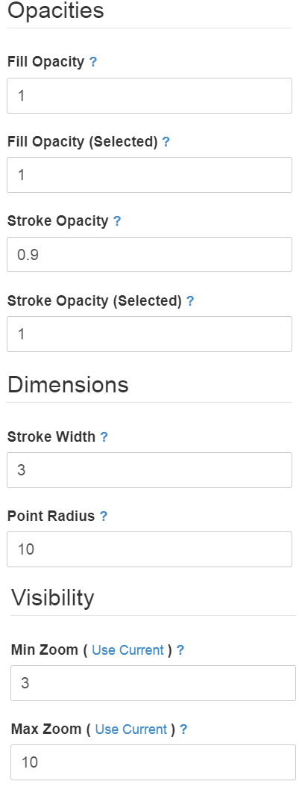A group Record’s informational popup can be edited via the *Body* section of the *Text* tab (there is an HTML interface option here for including hyperlinks and images).

* Each of the lines connecting two stars is its own Record. The line imagery is a Neatline Line made via *Draw Line* under the *Map* tab per Record. The *Style* guide is pictured to the right (additionally, the *Presenter* is set to None).

**General Organization of Site**

* The site uses the Seasons theme with the Night style sheet.
* Navigation: Home is custom redirected to /homepagemap, which is the Neatline exhibit containing the constellation visualization. The other pages on the nav bar include Narratives of Groups, Interviews, Galleries of Images, Instruments/Tools/Proposals (these four are *Collections)*, About, and Contribute an Item (a plugin that allows guest users to contribute to the repository).
* Each group, linked to star imagery in the Neatline homepage visualization, has its own *Exhibit* under which all materials related to the group can be found. Each Exhibit acts as a satellite ‘website’ off the main website for each group.
* Each thematic node in the Neatline visualization also has its own *Exhibit*, acting as a satellite ‘website’ off the main website for each theme. The *Exhibit* contains all materials relating to the theme in question.